# Amazon Rekognition Custom Labels Lab

## **Objectives**

In this workshop, we’ll learn the fundamentals of [Amazon Rekognition Custom Labels](https://aws.amazon.com/rekognition/custom-labels-features/) by building an AWS logo detector. This serves as an example of how to build models to enable brand monitoring and analysis through rich media channels like social media.

**Learn how to:**

1. Use the Amazon Rekognition Custom Labels console.
2. Prepare classification or object detection training and test datasets using Rekognition.
3. Train a custom object detection model with the help of Rekognition Custom Labels (AutoML) through few shot learning.
4. Deploy a Rekognition Custom Labels Demo app.
5. Manage the continuous improvement mechanics.

## **Setup your Lab Environment**

1. Pre-requisites:

* [Access](https://aws.amazon.com/free/) to AWS with permissions to the lab resources.
* [AWS CLI](https://docs.aws.amazon.com/cli/latest/userguide/cli-chap-install.html) installed on your workstation.

1. Launch the Amazon Rekognition Custom Labels demo app from [this](https://github.com/aws-samples/amazon-rekognition-custom-labels-demo) GitHub repository. Use the launch template buttons as displayed below from your preferred region.

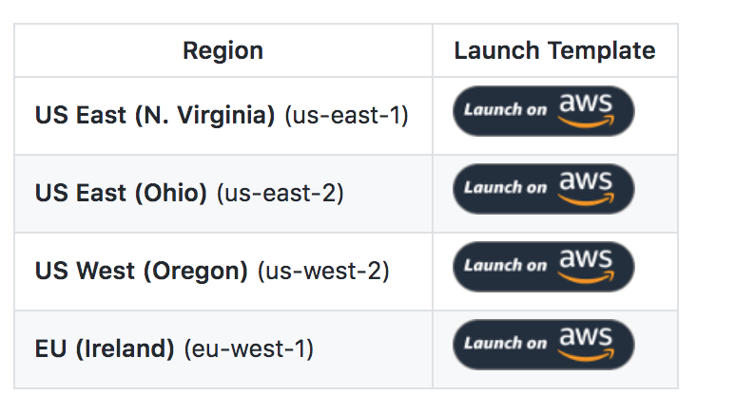

You don’t have to wait for the CloudFormation template to complete. Later you will log into the web app that it creates. You can access login URL from the **Output** sub tab.



1. Create an S3 bucket. You can use an existing S3 bucket, but you’re expected to have ownership and full access.
2. Copy the aws-logos dataset over to your S3 bucket using the AWS CLI:

aws s3 sync s3://dtong-public-fileshare/machine-learning/datasets/aws-logos/ **<<REPLACE WITH YOUR S3 URI>>**

eg) **<<REPLACE WITH YOUR S3 URI>>:** s3://dtong-ml-datasets/aws-logos

## Amazon Rekognition Custom Labels Console

1. Log into the AWS console and navigate to the Amazon Rekognition console. You can use the search bar.
2. Navigate to the Custom Labels console from the navigation panel on the left.



1. Ensure you’re accessing Amazon Rekognition in the same region as where you’ve provisioned the CloudFormation template and S3 bucket (Steps 2-3).



1. If this is your first-time accessing Amazon Rekognition Custom Labels, you’ll be prompted to provision an S3 bucket, which the service will be using to store meta-data. Click on the **Create S3 bucket** button to proceed.

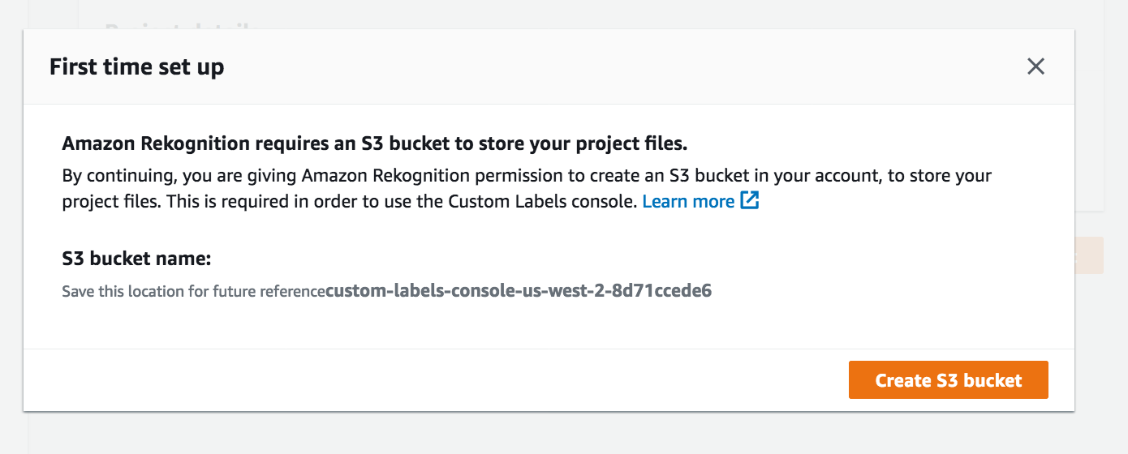

## Create a Project

1. Select projects from the navigation pane and click on the **Create project** button.
2. Enter a unique name for your project.



## Prepare Datasets

1. Navigate to the Datasets page and click on **Create dataset**.

## 

1. We’ll start by creating our training dataset. Provide a name to identify this dataset and select **Import images from Amazon S3 bucket**.

## 

1. Provide the S3 URI location of the training dataset. This location is the S3 URI that you provided as the destination of your sync command followed by the /train1/ prefix: *s3://<Your S3 URI>/train1/.*

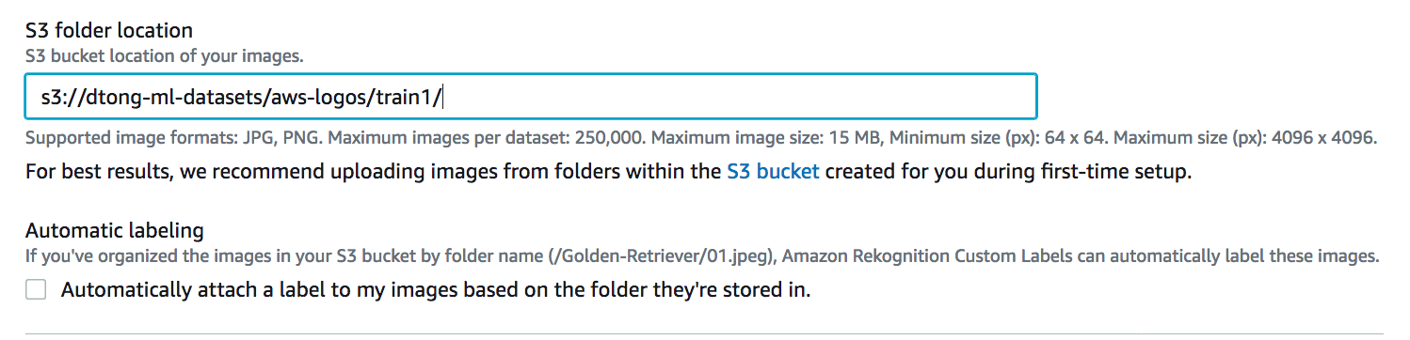

1. Amazon Rekognition requires access to your S3 bucket, so that we can do things such as storing image annotations and reading images for training and testing. Follow the provided instructions and copy the provided bucket policy as shown below:

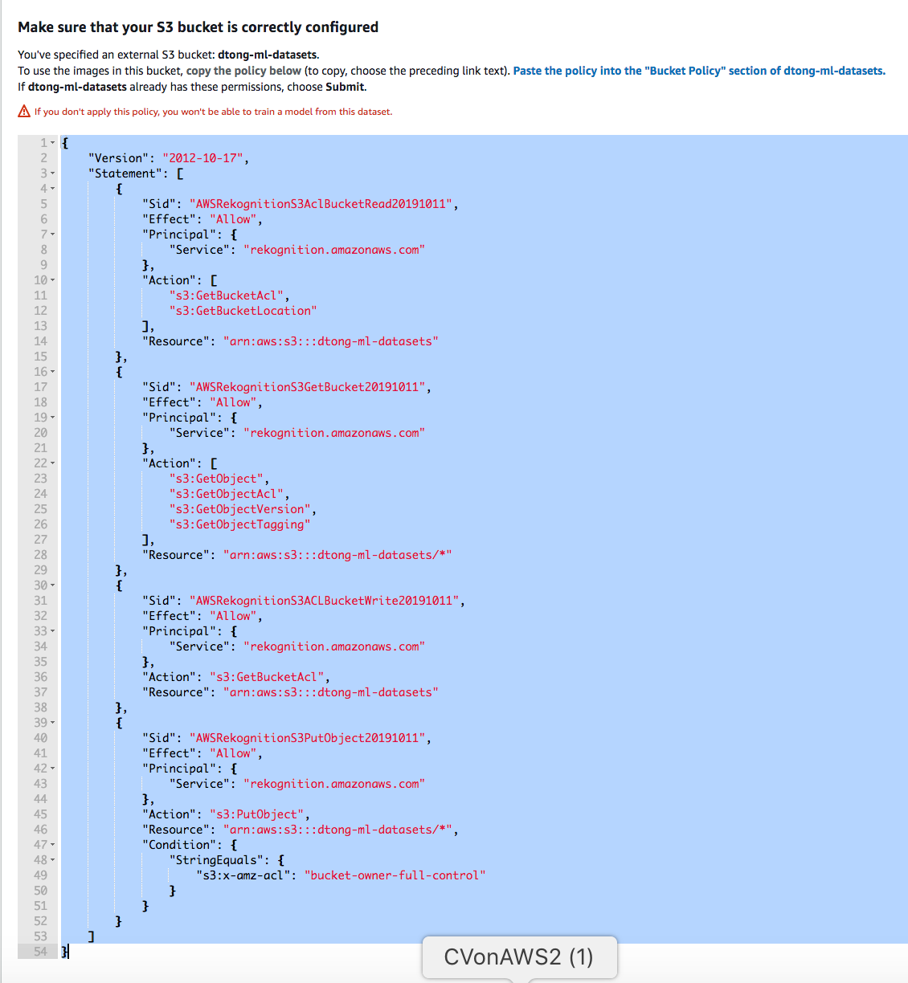

1. In a new browser tab, navigate to the S3 console and select your S3 bucket. Click on the **Bucket Policy** button under the **Permissions** tab.

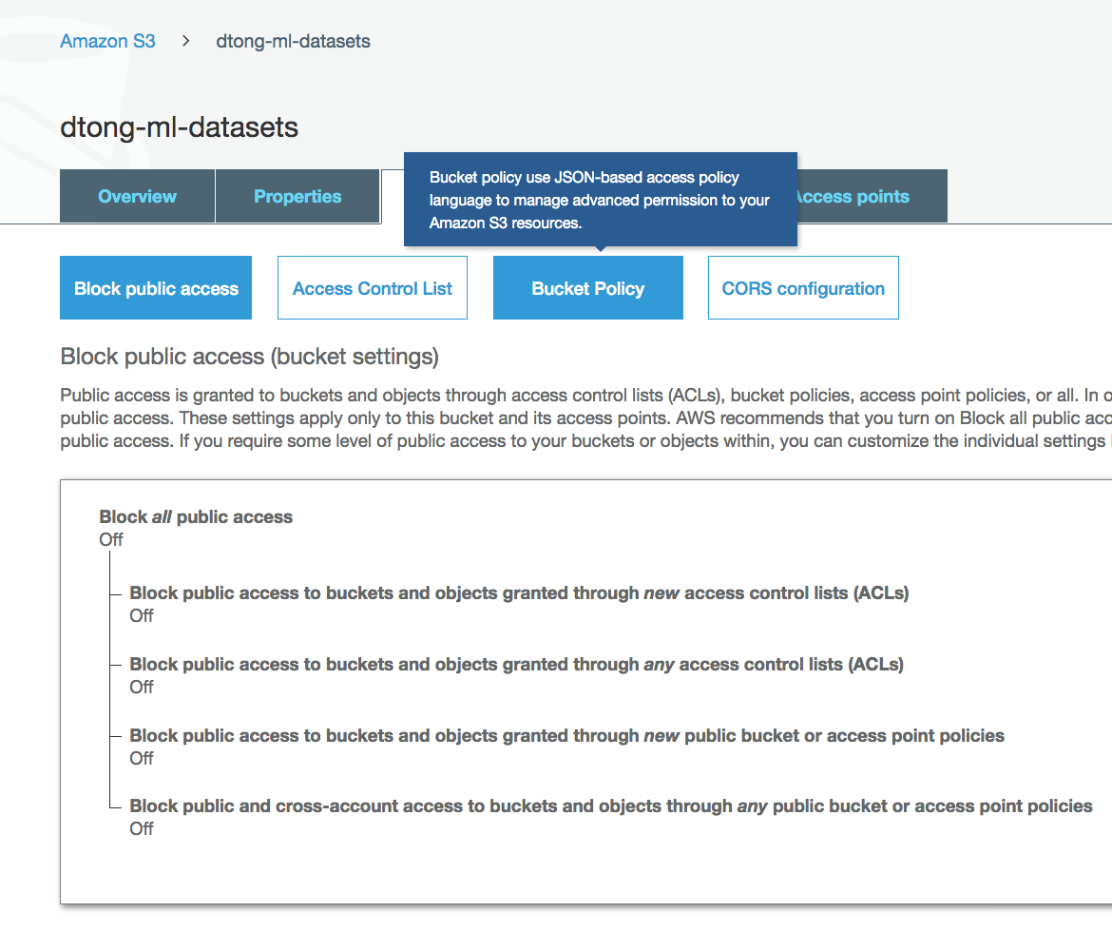

1. Paste the Rekognition Custom Labels bucket policy and click on **Save**.

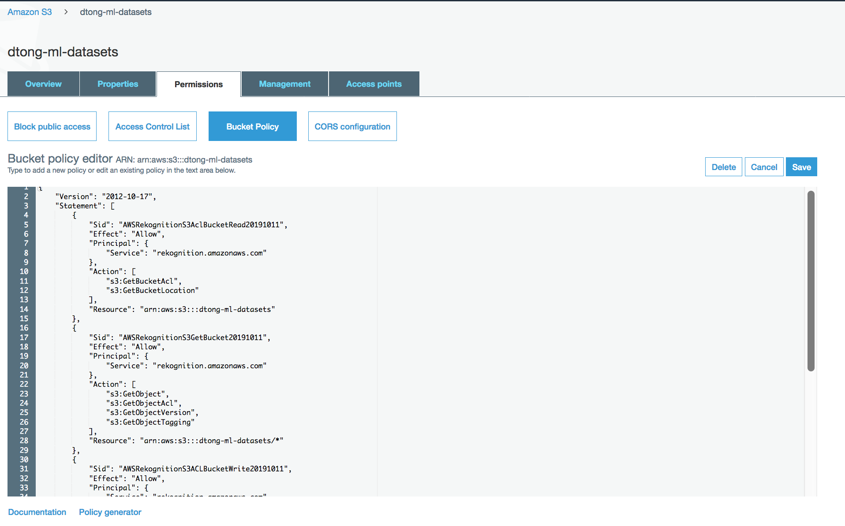

1. Return to the Rekognition Custom Labels console. Rekognition should now have access to your S3 bucket, so when you click on **Submit**, the dataset should be successfully created.

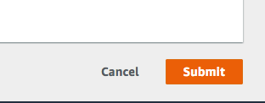

## Annotate Training Data using Amazon Rekognition Custom Labels

Amazon Rekognition requires annotations in a specific [format](https://docs.aws.amazon.com/rekognition/latest/customlabels-dg/cd-manifest-files.html). The easiest way to label your dataset is to use the integrated labeling tool, or Amazon GroundTruth. [Amazon GroundTruth](https://aws.amazon.com/sagemaker/groundtruth/) is the recommend option for production projects where you need to scale by manage labeling workforces and large training sets.

In this lab, we’re engaging in rapid prototyping and operating on a very small dataset. The integrated labeling tool is more practical for our purpose. Further down the developing process, you might choose to migrate over to Amazon GroundTruth as you transition into production.

1. After you create your training dataset, you should be re-directed to the details pane of the dataset. Click on the **Add** button the left-hand side panel to create a label.

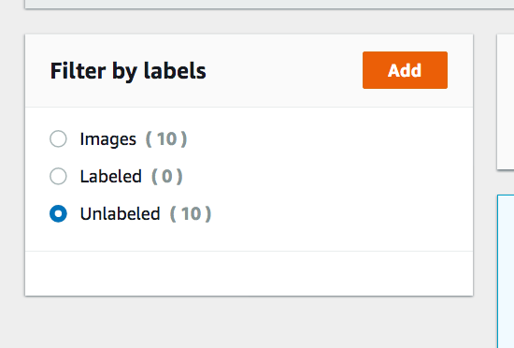

1. Type in “aws” and click on **Add label** to create a single label. Click on the **Save** button.

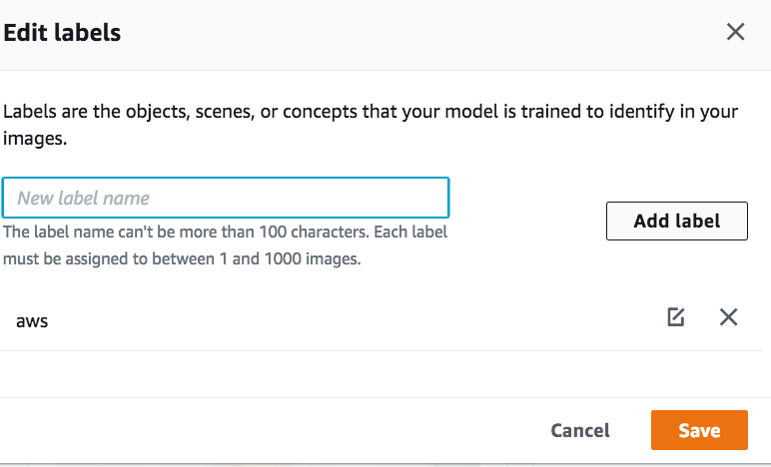

1. Click on the **Start Labeling** button to enter the embedded labeling tool for Rekognition Custom Labels.



1. Select each of the images displayed on the page. Unfortunately, you can’t select images on the next page, so select the first 9 images.

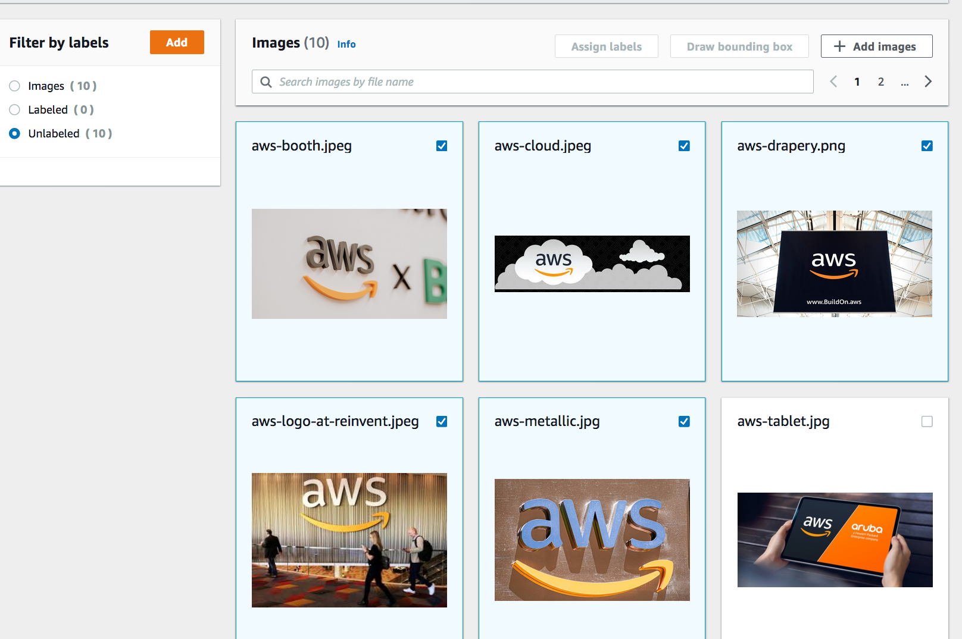

1. Click on the **Draw bounding box** button.

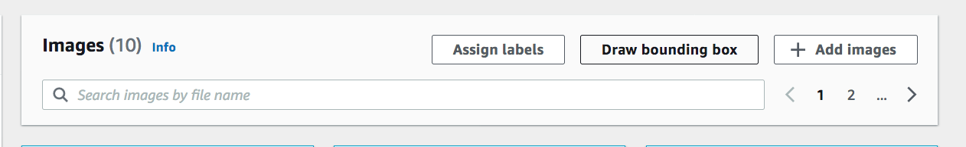

1. You’re now in the annotation tool context. The bounding box tool at the bottom of the editor should be selected by default.

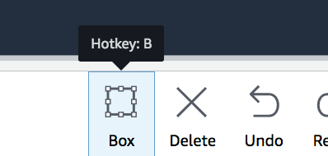

1. Click, drag and release to create a bounding box around the AWS logos.

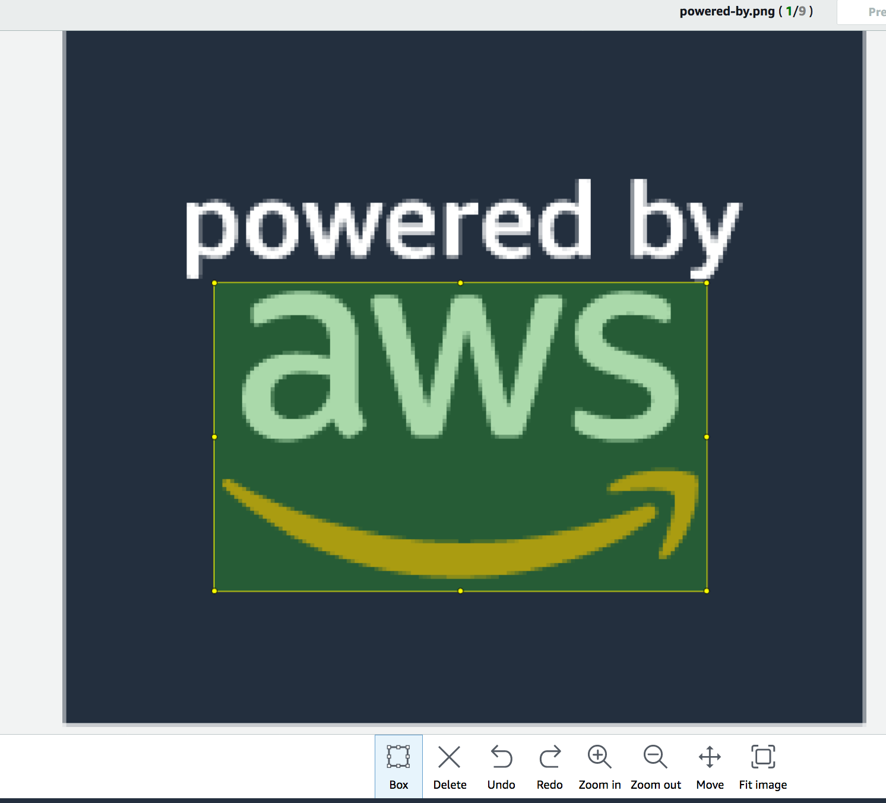

1. Click on the **Next** button after you’ve completed annotat

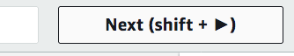

1. After you’ve annotated the last selected image, you can press the **Done** button.

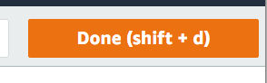

1. **IMPORTANT:** after pressing the done button, you’ll return to the datasets pane. Click the **Save changes** button. Any other action could result in losing your work.

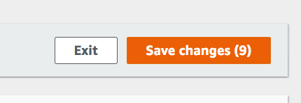

1. We have 10 images to label. You can select the **Unlabeled** radio button to display the remaining image. Select the image and repeat the process to label the last image.

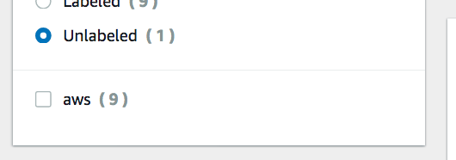

1. You should now have 10 labeled images, which you can preview from the dataset details pane as shown below:

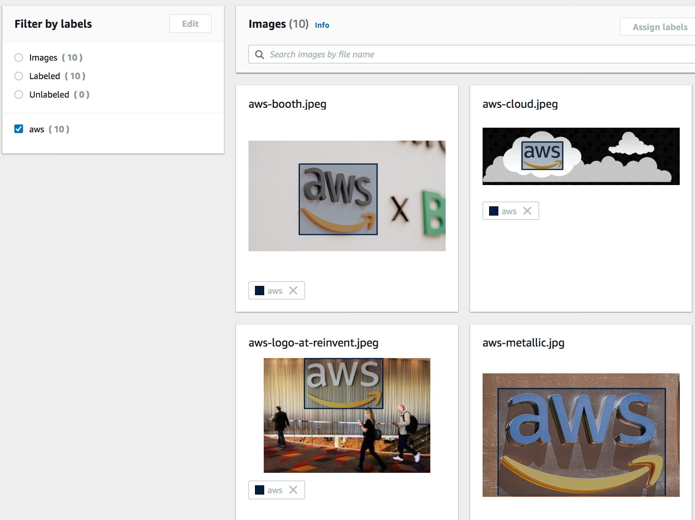

## Import your Test Dataset

Rekognition Custom Labels can perform a split and generate a validation dataset for you automatically during training, or you can provide a separate test dataset. We’re going to do the latter, so that we have a standard dataset that we can use as a test across multiple models.

The test dataset has been labeled using Amazon GroundTruth. Rekognition Custom Labels allows you to import these annotations. You simply need to provide the output.manifest generated by the service.

1. Download the output.manifest at: ***s3://<<Your S3 URI>>****/test-labels/aws-logos-test/manifests/output/output.manifest.*

The manifest file needs to be modified so that it references the resources in your S3 bucket. Open the manifest file and perform a find and replace:

Find:

*dtong-public-fileshare/machine-learning/datasets/aws-logos/test*

Replace with:

***s3://<<Your S3 URI>>****/test*

Upload the modified output.manifest back to the S3 location.

1. Select **Datasets** from the navigation panel and click on the **Create dataset** button.

Select **Import Images labeled by Amazon SageMaker Ground Truth.**

Set the manifest file location as: ***s3://<<Your S3 URI>>*** */test-labels/aws-logos-test/manifests/output/output.manifest*

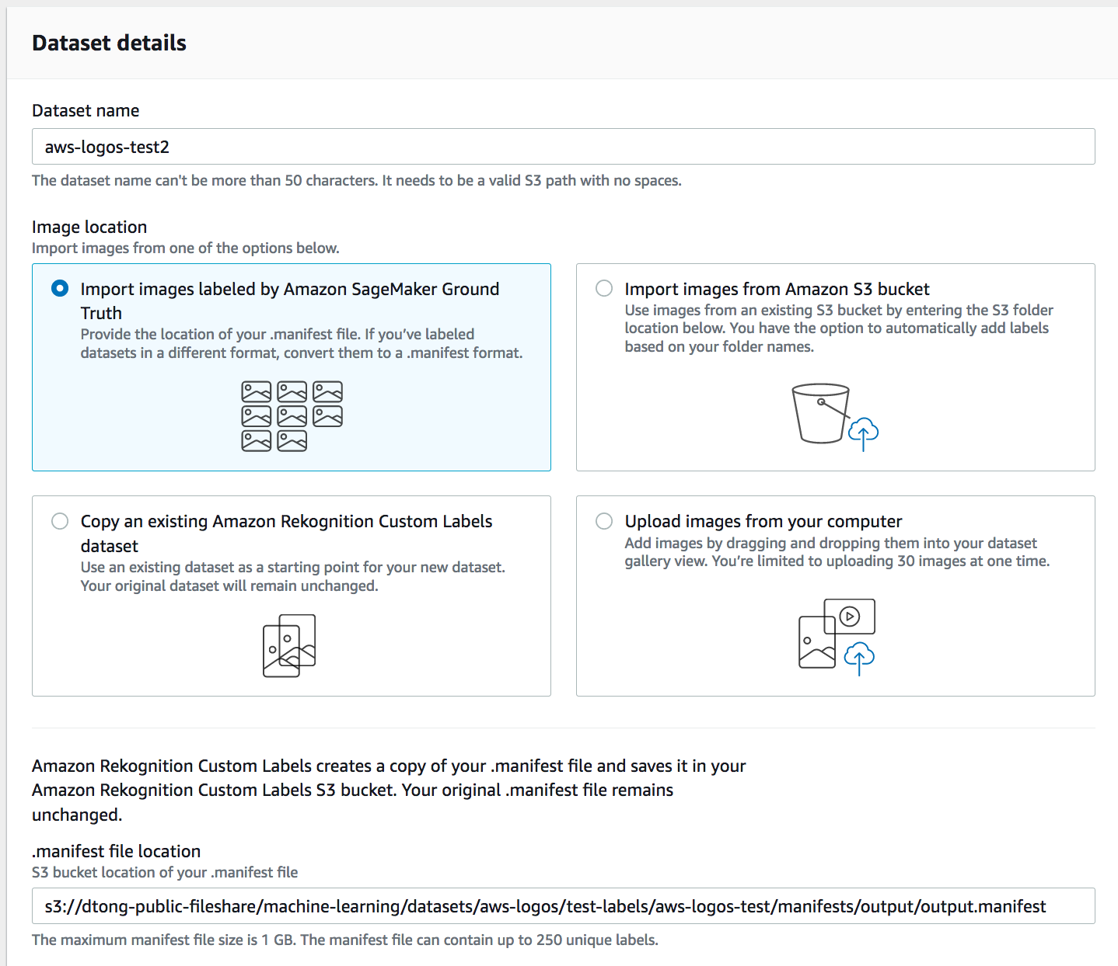

Note that you don’t need to copy the bucket policy again. The default bucket policy that you copied over previously provides permissions to all the contents in the S3 bucket.

## Train Your Model

1. Navigate to the **Projects** panel and select the project that you created. Your project should look similar to the image below. Click on the **Train new model** button.

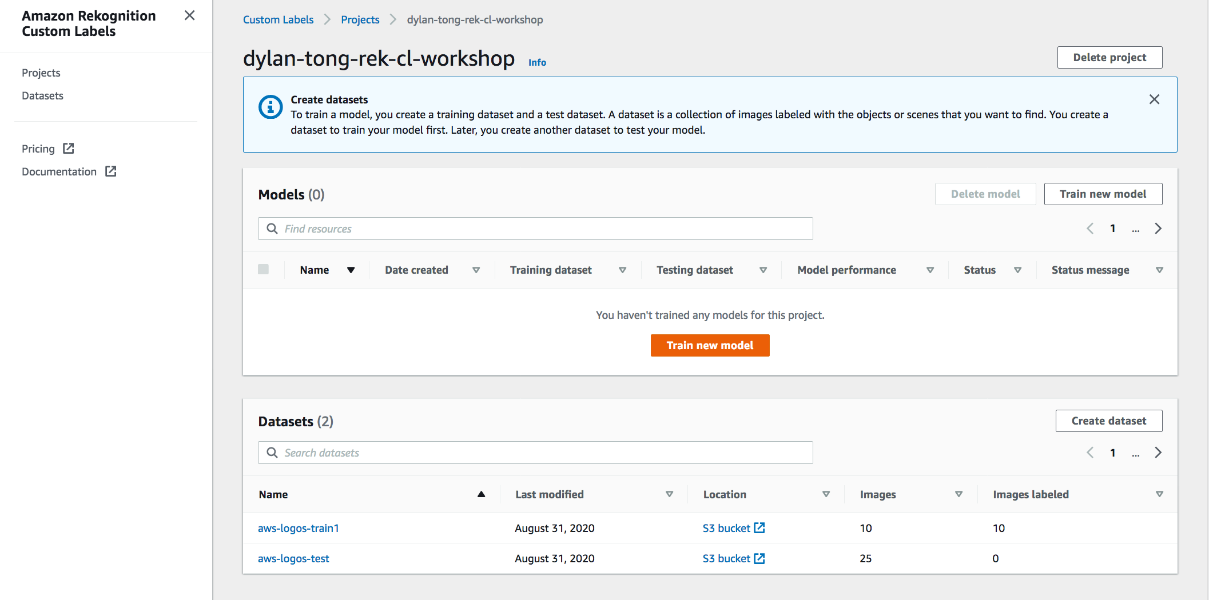

1. Under **Choose training dataset**, select the name of the training dataset that you created.

Select **Choose an existing test dataset**. Select the name of the test dataset that you created.

Lastly, Click on the **Train** button.

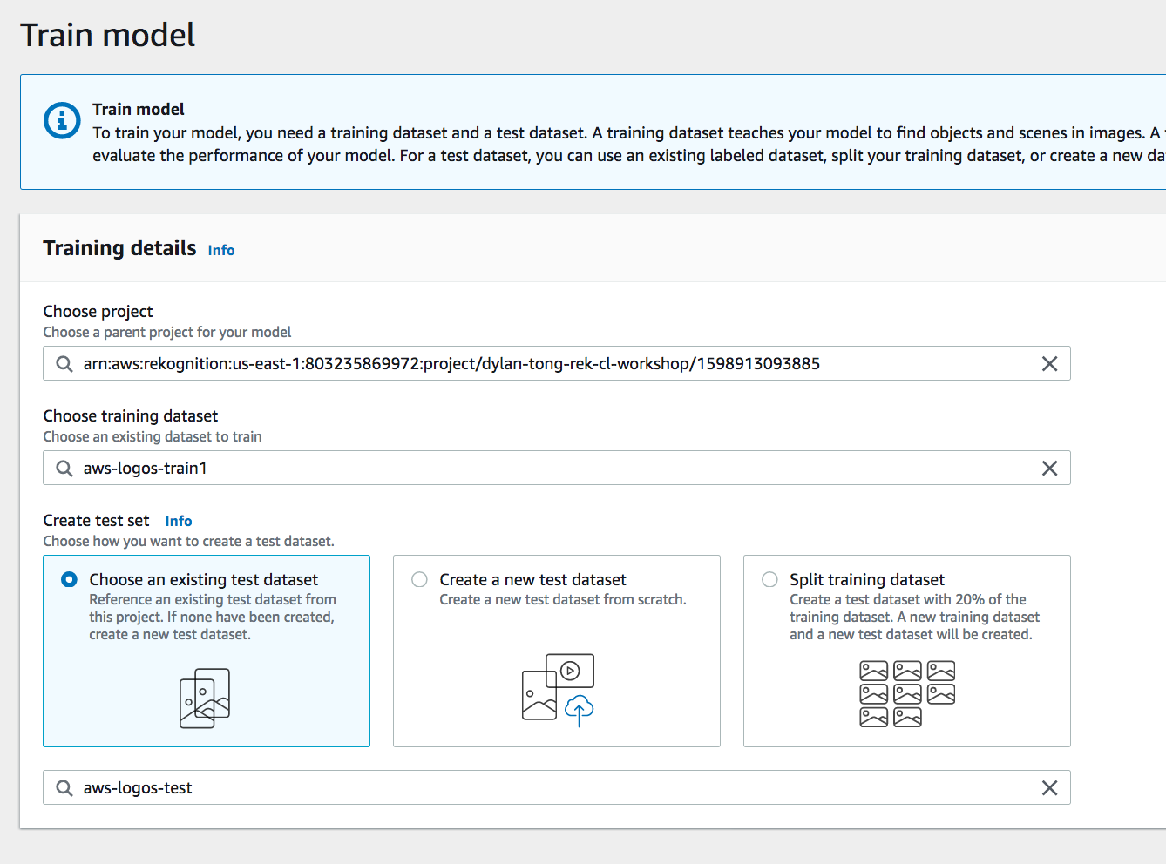

1. From your Projects detailed pane. You should see your training job running:

*The job will take 1-3 hours to complete.*

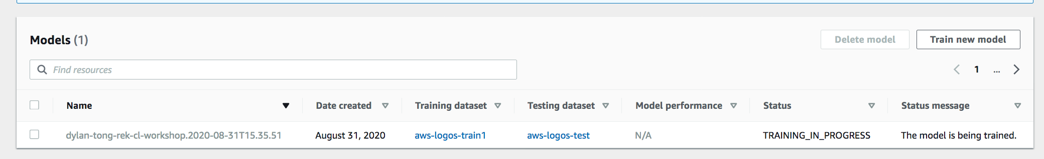

## Evaluate your Model

1. Once your model is trained, you can click on the model name from the console.

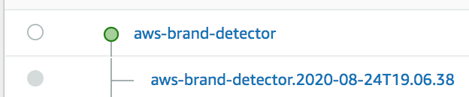

1. The models detailed pane provides a summary of evaluation results. You can click on **View test results** to analyze the predictions on the test dataset.

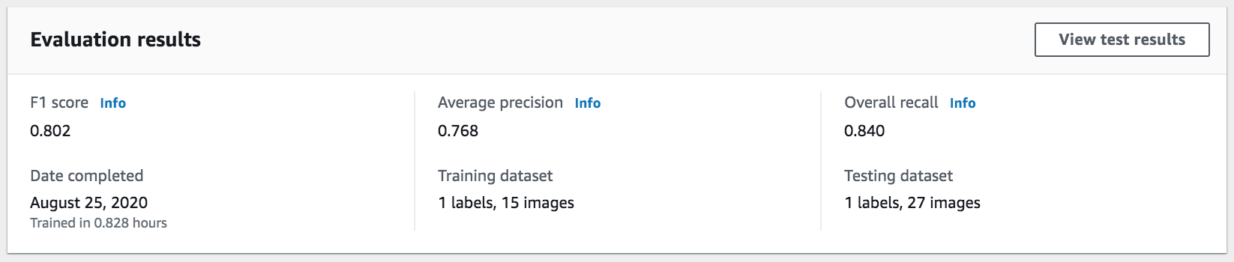

Flip through the images to perform error analysis.

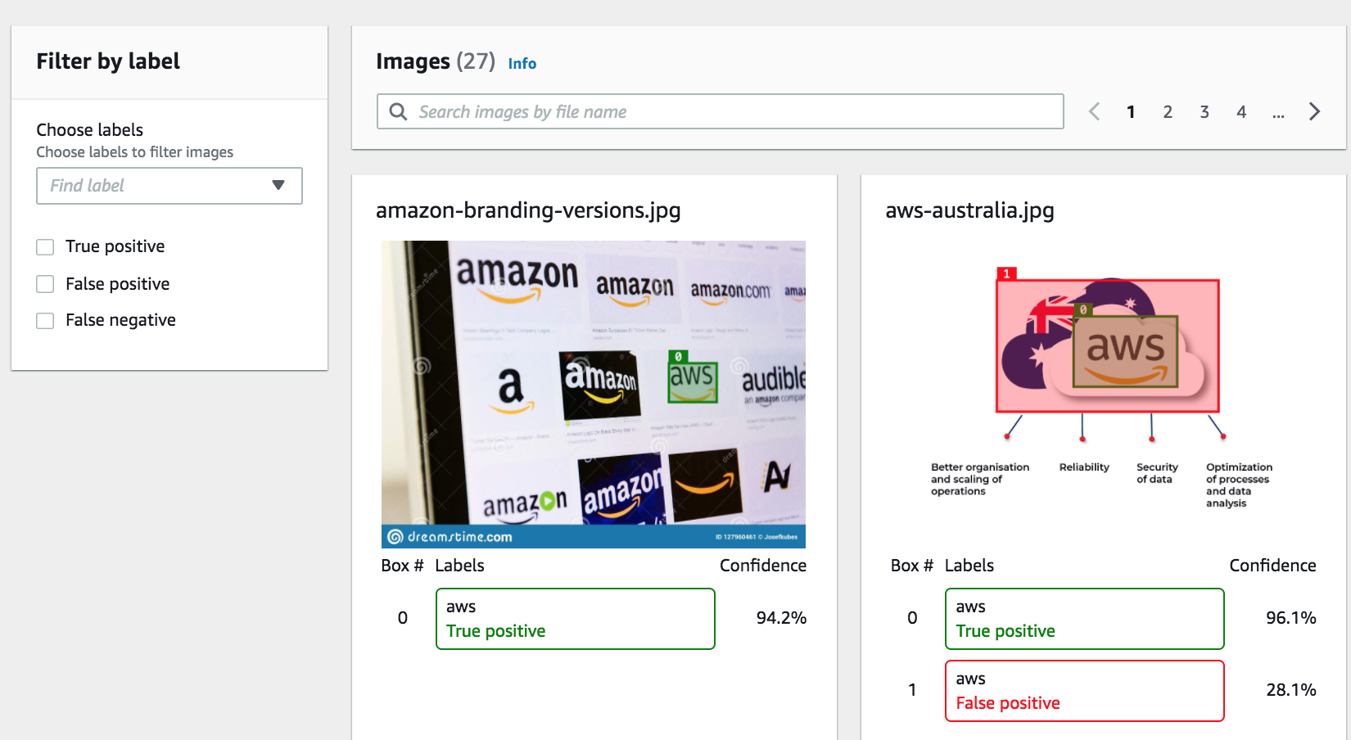

## Deploy your Model

1. From the model details pane, you find API code to deploy your model using the AWS CLI. Alternatively, you can use the [SDK](https://docs.aws.amazon.com/rekognition/latest/customlabels-dg/rm-start-model-sdk.html).

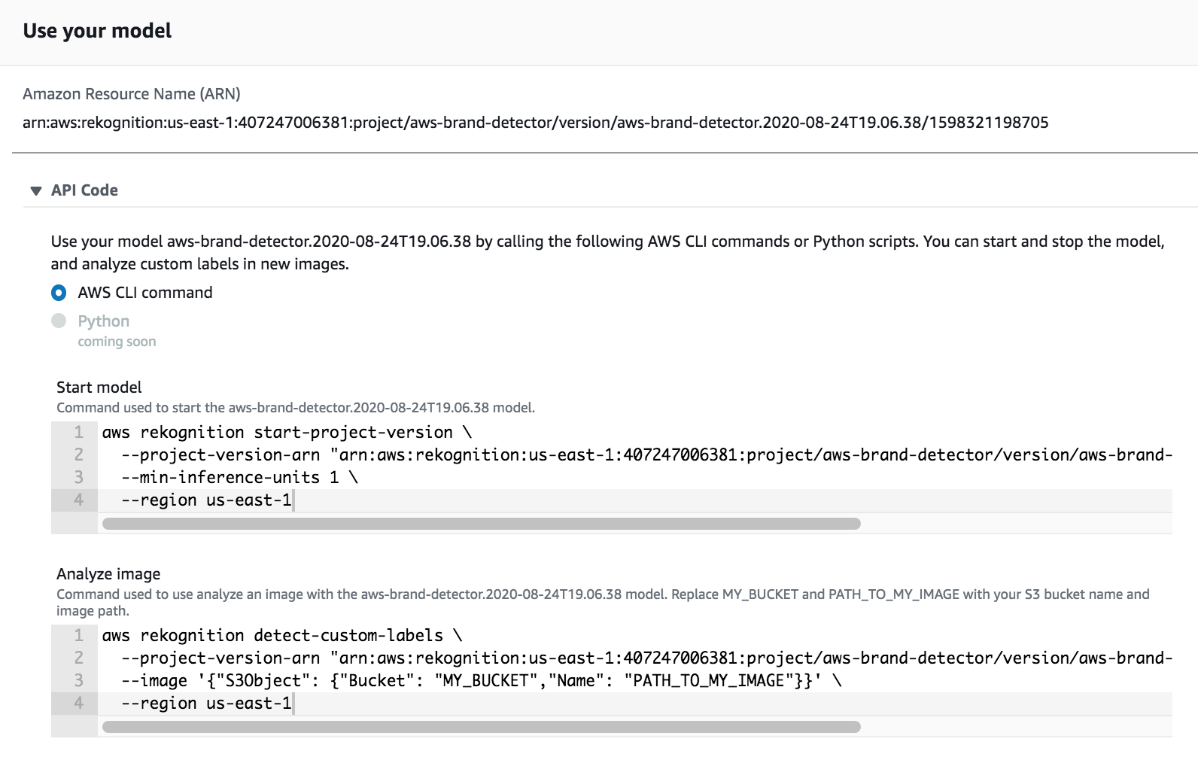

1. We’re going to use the Demo app that you deployed previously to start and test the model. Check your email to acquire your temporary password.

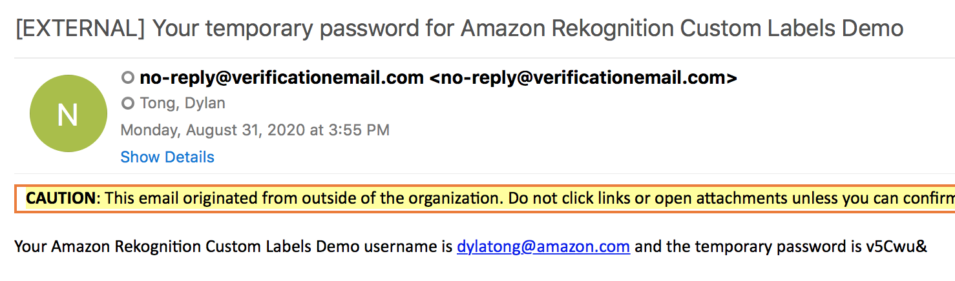

1. Return to the CloudFormation console. Select your template and click on the URL under the **Output** sub panel.



1. Log into the demo app with your temporary credentials and change your password.
2. Click on the **Start Model** button from the main page. Enter **1** as the number of inference units and click on the **Start Model** button. This will take *5-15 minutes* to complete.

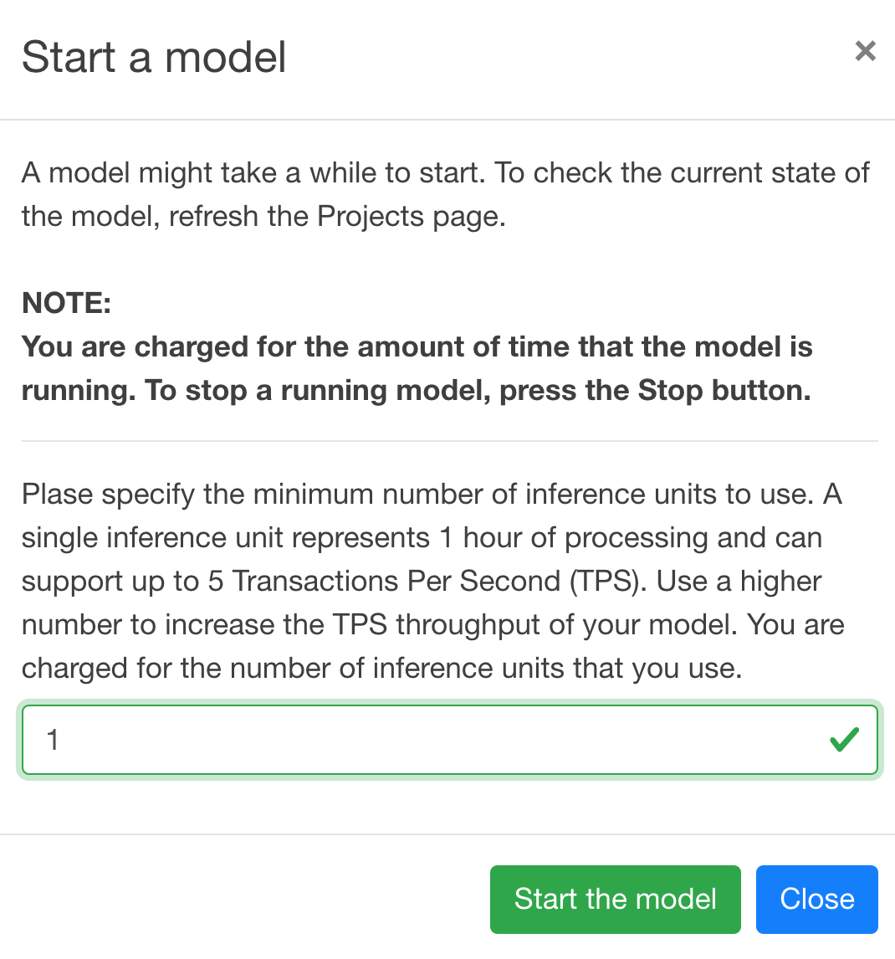

1. Once your model is running, click on the name. You can upload an image to test your model.

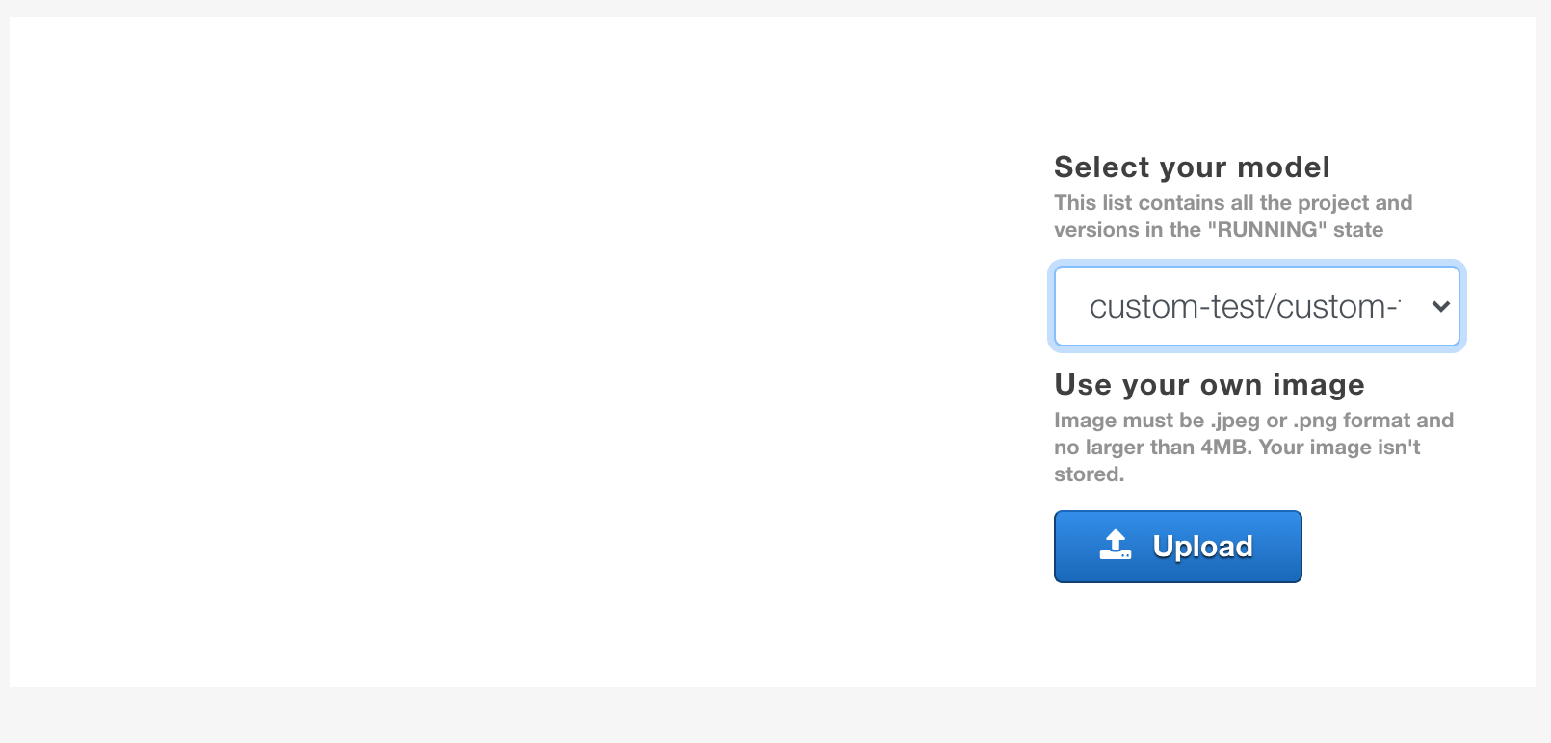

## Improve your Model

If you inspect the training set, you’ll notice that the images are basic. Many of the images are high quality images of the logos. These images don’t represent how you’ll use the model in your production application.

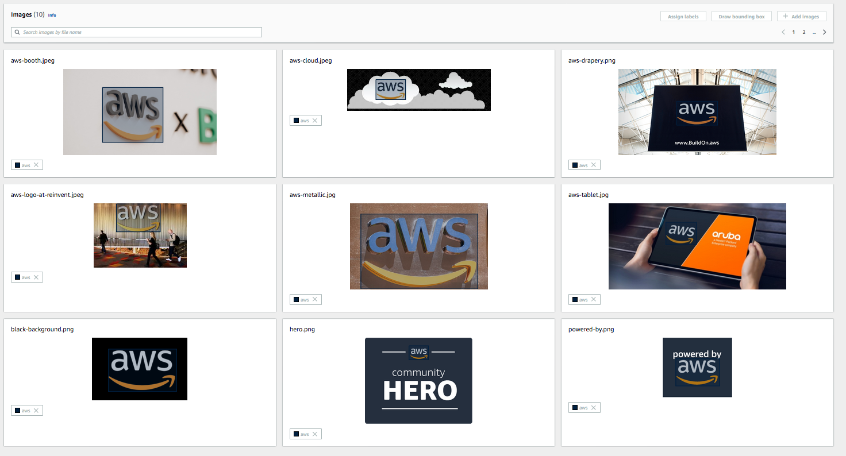

Rekognition Custom Labels performs various image augmentation and processing techniques to create a more robust model from your dataset. However, training images more like what you expect to see in production will improve your model.

1. Create a new training dataset by repeating the same process as before.

Note that there are multiple ways to import new datasets. You could create this new dataset using the first training dataset then add and label images ad-hoc.

At production scale, this process would be better managed through Amazon GroundTruth. GroundTruth datasets can be imported into Rekognition Custom Labels.

The overlap between the first and second training dataset is minimal. Since there’re only 14 images, it’s quicker to create and label a new dataset from scratch through the Rekognition Custom Labels tooling.

The second training dataset is located at: *s3://<Your S3 URI>/train2/.* Label all the images by following the same process as before.

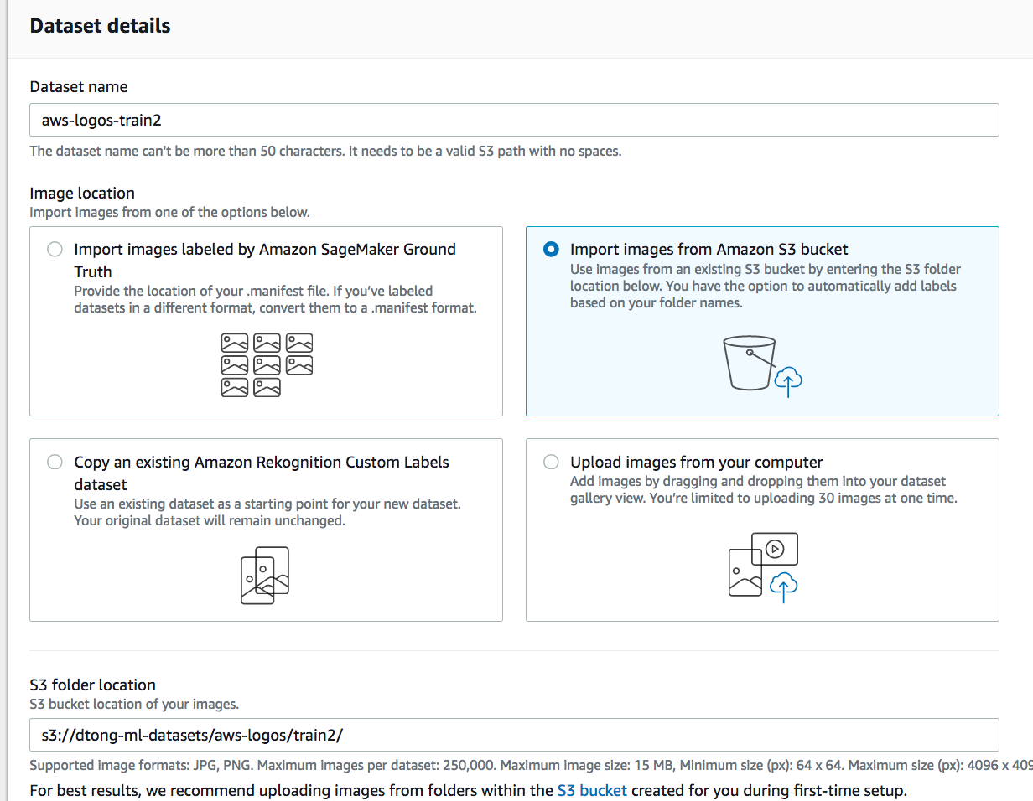

1. Click on **Train Model** again. This will train and track a second version of your model under the same project. Use the same test dataset and select the new training dataset that you just created. *This will take another 1-3 hours to complete.*

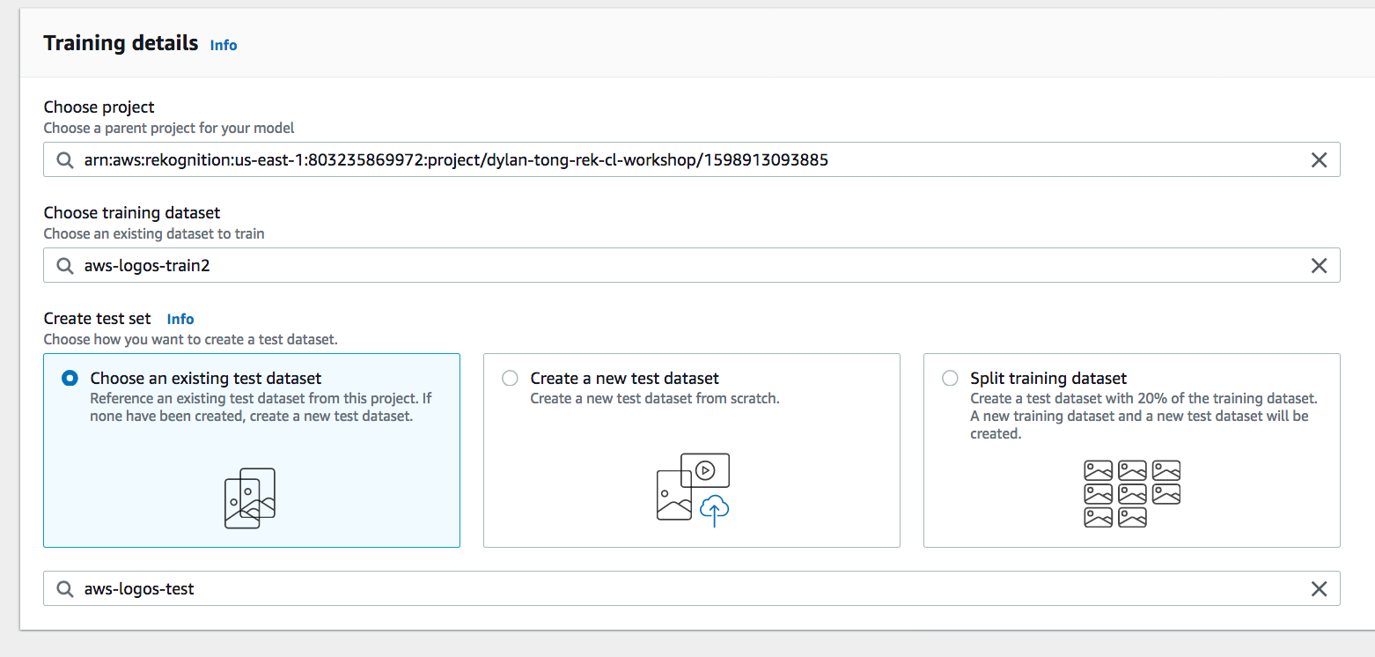

1. Take a second look at this second training dataset and the first. Notice that it’s more robust than the previously.

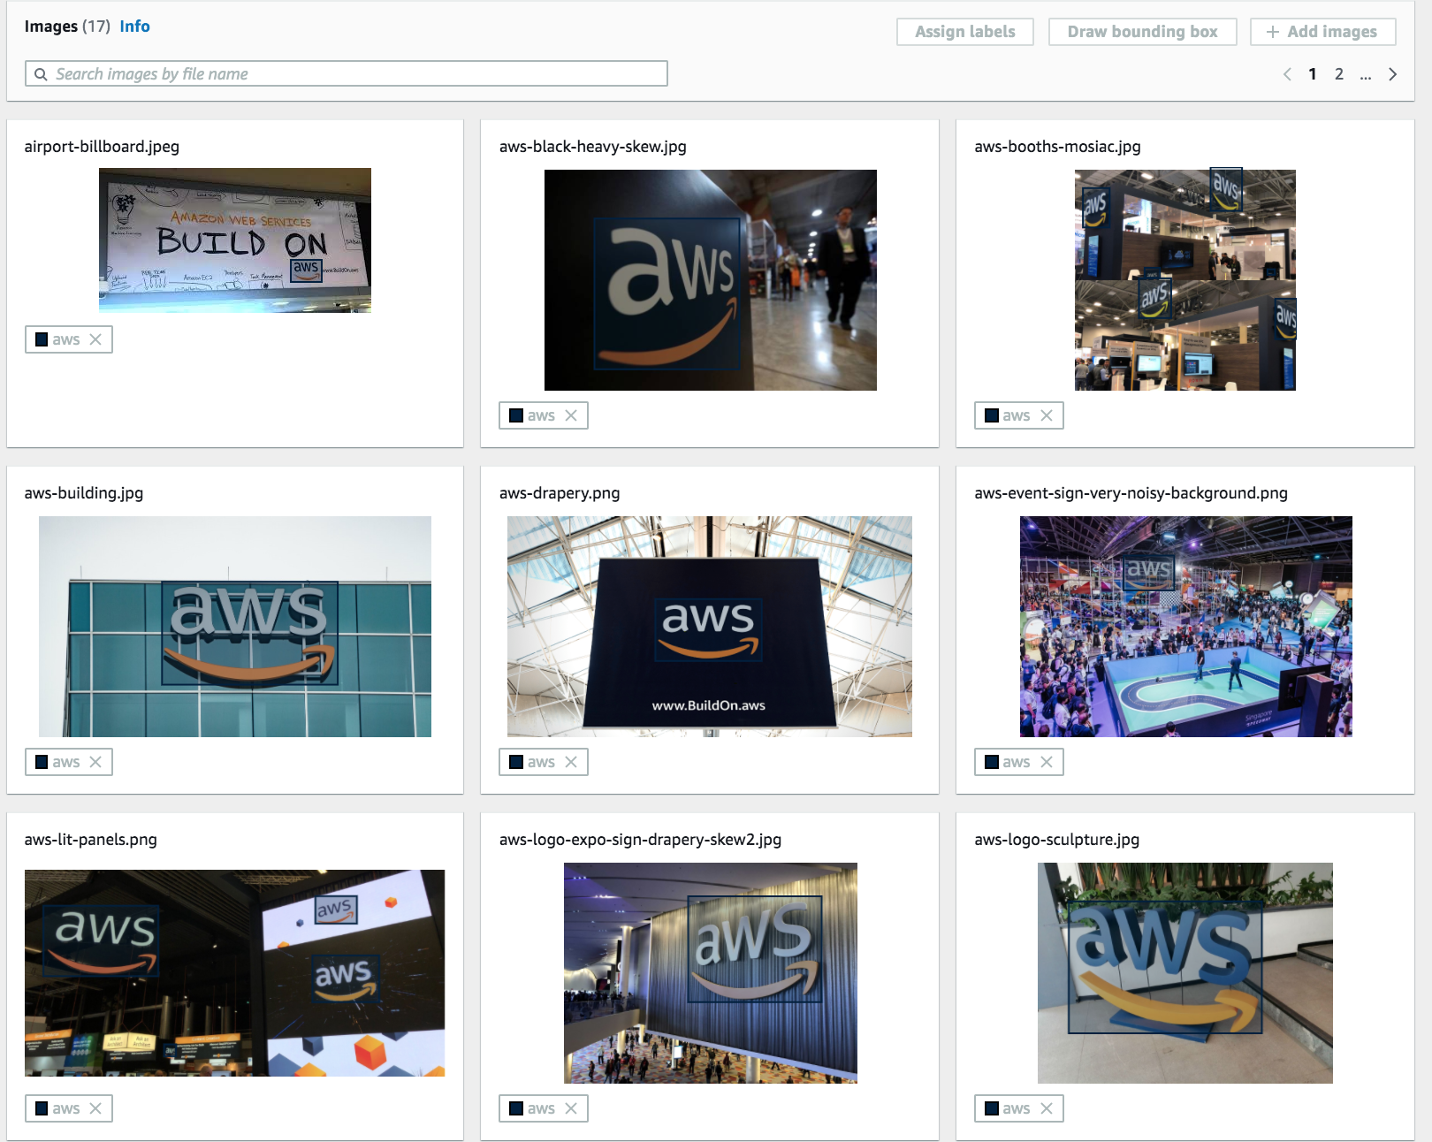

1. As you improve your dataset through error analysis and human feedback in production, you can re-train, track and evaluate model improvements.

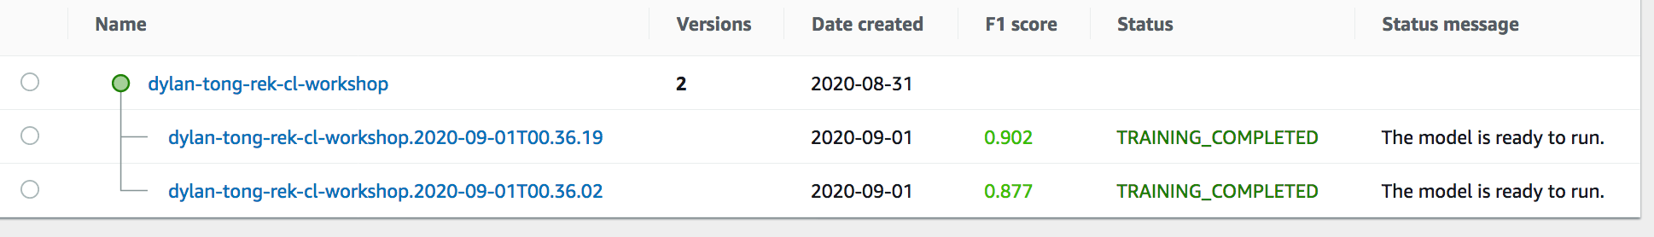

## Next: Productionizing Your Models

Congratulations, you’ve completed this lab!

As you take your Rekognition Custom Label models into production consider the following:

1. In production, you should roll out your training and deployment process in a repeatable and automated process. A workflow engine like [AWS Step Functions](https://aws.amazon.com/step-functions/) could serve this need.
2. You should consider more granular and automated tested. Rekognition provides summary evaluation metrics and a way to manually inspect the predictions on your test set. In production, it’s desirable to be able to perform granular error analysis—for instance, be able to compare the training and test performance for each class in an automated fashion to detect issues between model versions. This is necessary as you scale your datasets. You can automate this step using AWS Step Functions and the Rekognition [SDK](https://docs.aws.amazon.com/rekognition/latest/customlabels-dg/detecting-custom-labels.html).
3. Manage your labels with [Amazon GroundTruth](https://docs.aws.amazon.com/sagemaker/latest/dg/sms.html) as your datasets grow.
4. Having a human feedback loop is important for identify issues with your model in production and capture errors so that this data can be used for re-training and improving your model. You can use [Amazon Augmented AI](https://aws.amazon.com/augmented-ai/) (A2I) for this purpose. Here’s a Jupyter Notebook that [demonstrates](https://github.com/aws-samples/amazon-a2i-sample-jupyter-notebooks/blob/master/Amazon%20Augmented%20AI%20(A2I)%20and%20Rekognition%20DetectModerationLabels.ipynb) how to use A2I with Rekognition.

## Additional Learning Resources

[Documentation](https://github.com/aws-samples/amazon-a2i-sample-jupyter-notebooks/blob/master/Amazon%20Augmented%20AI%20(A2I)%20and%20Rekognition%20DetectModerationLabels.ipynb)

[Human Feedback for Rekognition Lab](https://github.com/aws-samples/amazon-a2i-sample-jupyter-notebooks/blob/master/Amazon%20Augmented%20AI%20(A2I)%20and%20Rekognition%20DetectModerationLabels.ipynb)

[Media Insights Solution using Amazon Rekognition](https://github.com/awslabs/aws-media-insights-engine)